**Create new Django projest (command line)**

VIRTUAL ENV MUST BE ACTIVATED!

DJANGO MUST BE INSTALLED!

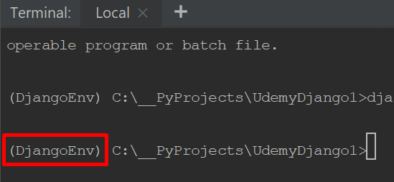

**COMMAND:**

django-admin startproject [project name]